STARAGILE JENKINS ASSIGNMENT -2

Step 1: Create an AWS EC2 Ubuntu Instance (Jenkins-master)

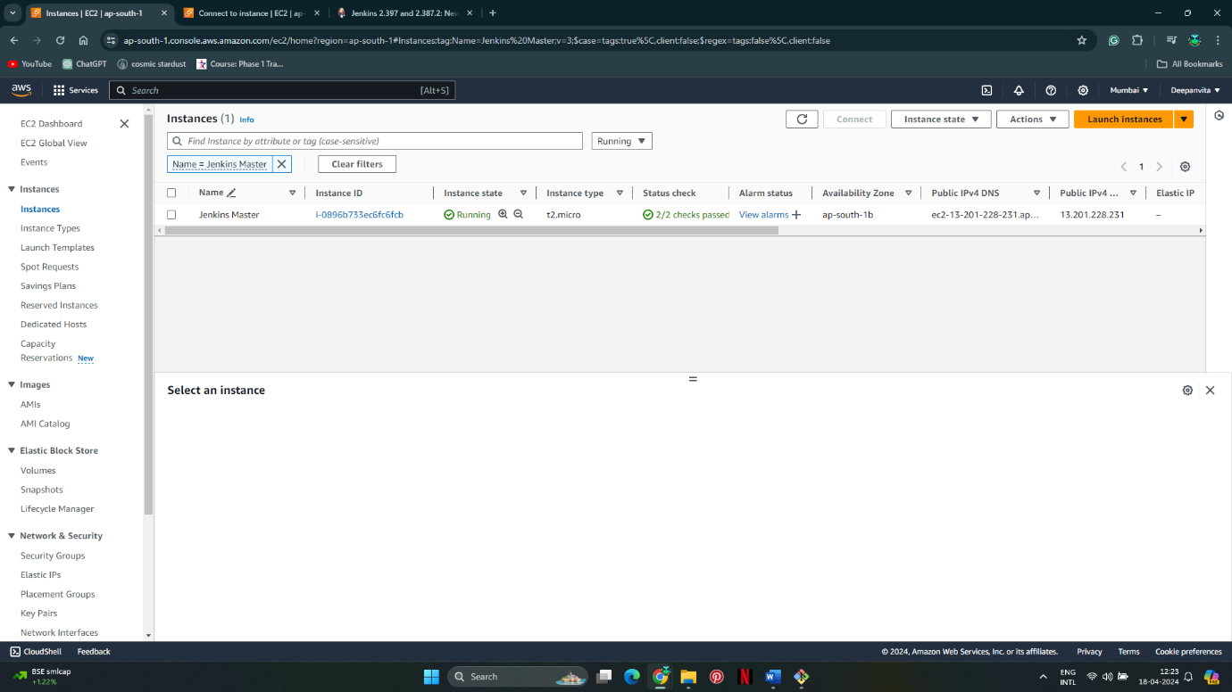

Step 2: Setup Jenkins on Jenkins-master

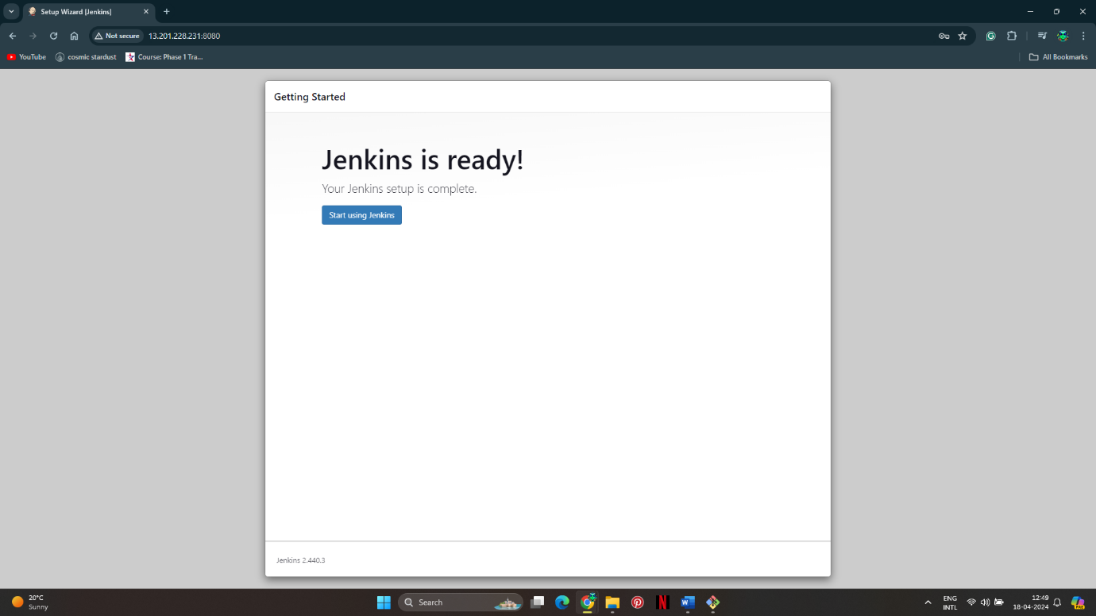

Step 3: Add another AWS EC2 Ubuntu Instance (Jenkins-slave)

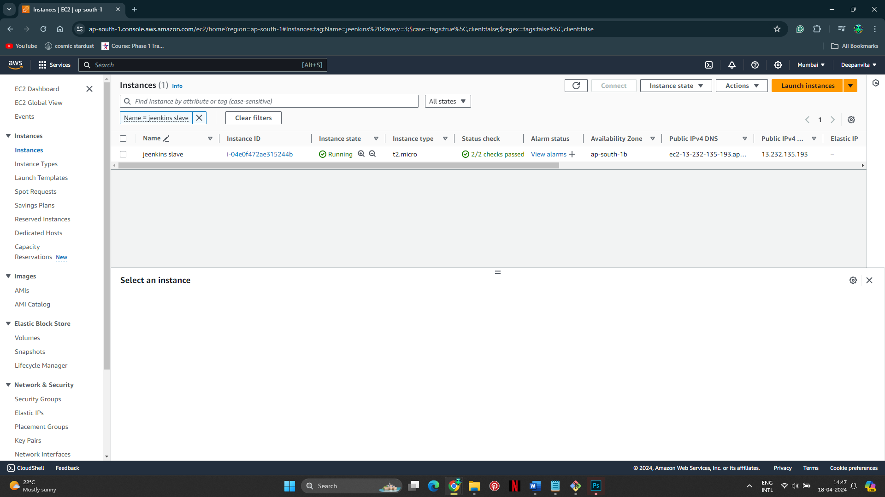

Step 4: Add Jenkins-slave as a Node to Jenkins-master

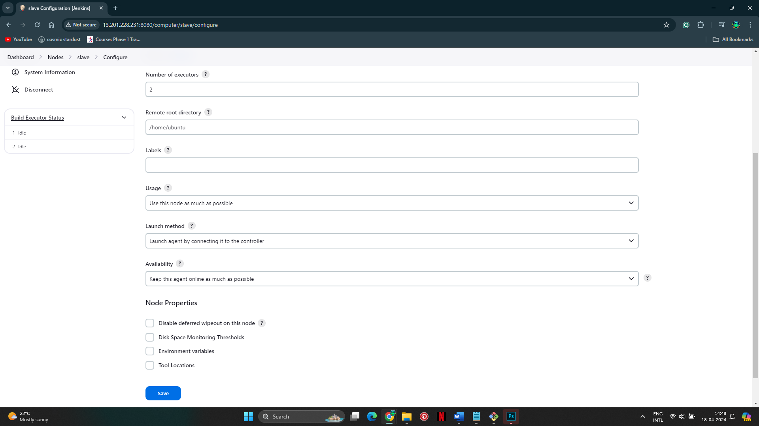

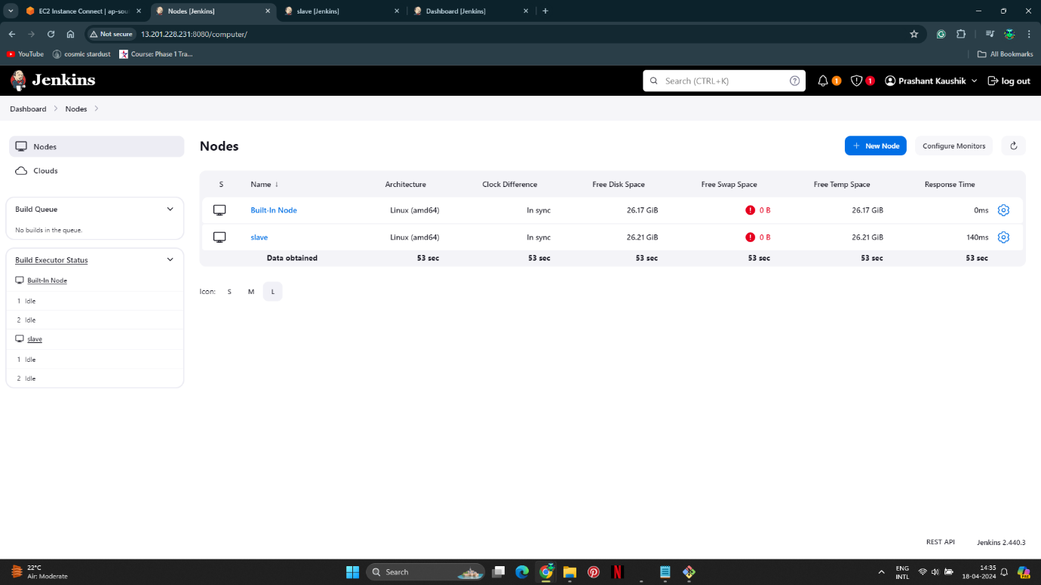

Step 5: Configure the Pipeline Script

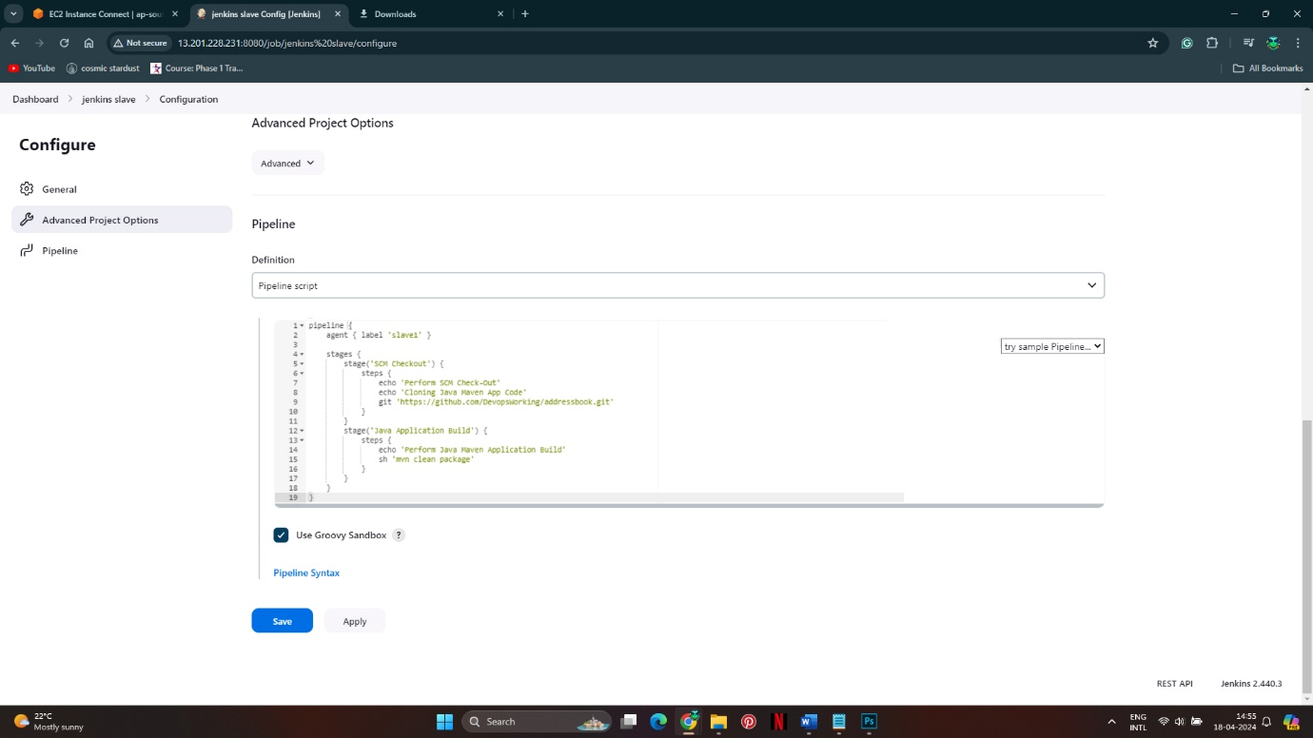

Step 6: Trigger the Build on Master and Verify

